**Good Extracts**

**Application Design Report**

**Prepared By: Jae Doyne**

December 2020

# Contents

Project Technologies and Data 2

Proposed Site Map 3

Key Pages Wireframing 4

UML Class Diagrams 5

Database Design 6

# Project Technologies and Data

* Front end – HTML, CSS, JS, React
* Back end – MySQL, NodeJS, ExpressJS, EJS
* Tools – Git
* Data – Location external APIs, own database

Front end

Back end

Database

Security

Frameworks

Tool set

Design principles

Data flow

**Architecture Diagram**

# Proposed Site Map

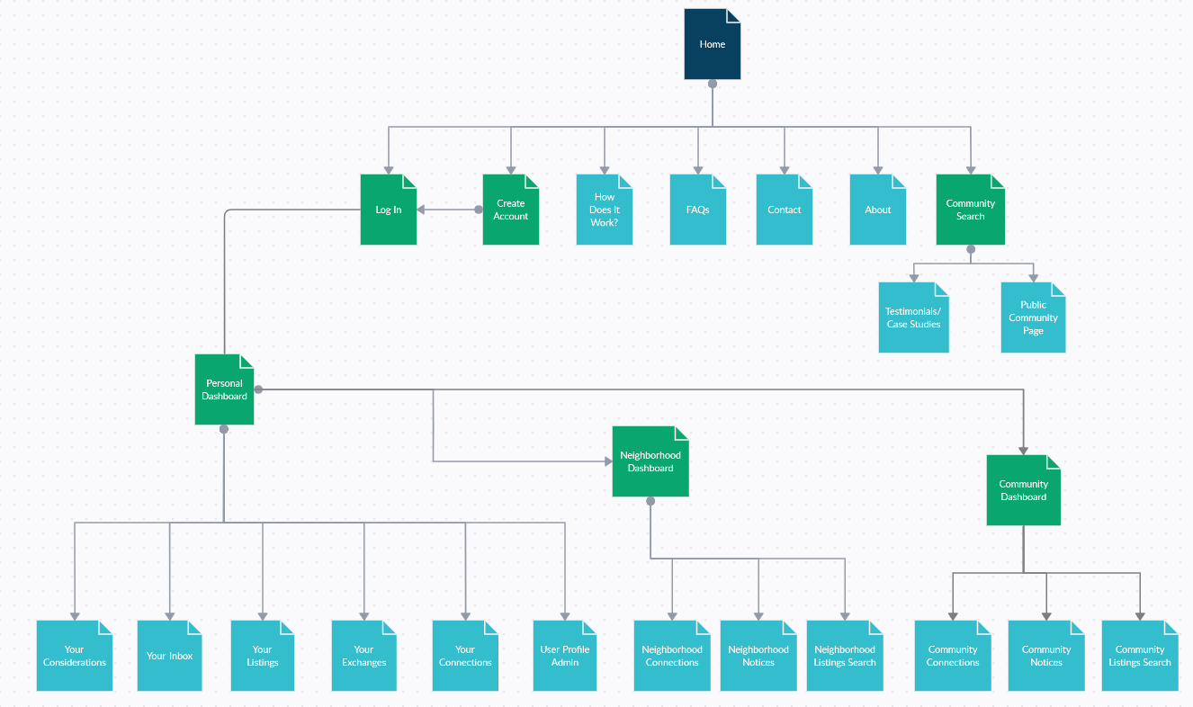

# 

# Key Pages Wireframing

# Class Diagram

# Database Design

Data Types and Inputs, Validation